**Bahria University,**

**Karachi Campus**

**COURSE:**

**DATA MINING**

**Term: Spring 2024**

**Class: BSE- 6(B)**

**Submitted By:**

**NAME: AIMAN ZIA SATTI**

**ENROLLNMENT: 02-131212-028**

**Submitted To:**

**DR. HINA SHAKIR / ENGR.HAMZA**

**Signed Remarks:**

**INDEX**

|  |  |  |  |  |
| --- | --- | --- | --- | --- |
| **SNO** | **DATE** | **LAB NO** | **LAB OBJECTIVE** | **SIGN** |
| **01** | **14-2-24** | **01** | Gui In Python Using Google Colab & Data Mining Libraries |  |
| **02** | **21-2-24** | **02** | Exploratory Data Analysis Using Python Best EDA Libraries |  |
| **03** |  |  |  |  |
| **04** |  |  |  |  |
| **05** |  |  |  |  |
| **06** |  |  |  |  |
| **07** |  |  |  |  |
| **08** |  |  |  |  |
| **09** |  |  |  |  |
| **10** |  |  |  |  |
| **11** |  |  |  |  |
| **12** |  |  |  |  |
| **13** |  |  |  |  |
| **14** |  |  |  |  |
|  |  |  |  |  |
|  |  |  |  |  |
|  |  |  |  |  |
|  |  |  |  |  |
|  |  |  |  |  |

**Bahria University,**

**Karachi Campus**

**LAB NO. 02**

**LIST OF TASKS**

|  |  |
| --- | --- |
| TASK NO | OBJECTIVE |
| 01 | * 1. Perform a basic data profiling to understand the structure of the dataset, including the number of rows, columns, and data types.   2. Identify the target variable and the predictor variables.   3. Compute summary statistics (mean, median, standard deviation, etc.) for each numerical variable.   4. Identify missing values and their distribution across variables. |
| 02 | * 1. Perform a basic data profiling to understand the structure of the dataset, including the number of rows, columns, and data types.   2. Identify the target variable and the predictor variables.   3. Compute summary statistics (mean, median, standard deviation, etc.) for each numerical variable.   4. Identify missing values and their distribution across variables. |
| 03 | * 1. Identify potential outliers in the dataset using appropriate techniques, such as box plots, scatter plots.   2. Visualize the distribution of each numerical variable to identify any extreme values.   3. Discuss the potential impact of outliers on the analysis and modeling process. |
| 04 | * 1. Identify potential outliers in the dataset using appropriate techniques, such as box plots, scatter plots.   2. Visualize the distribution of each numerical variable to identify any extreme values.   3. Discuss the potential impact of outliers on the analysis and modeling process. |

**Submitted On:**

***22nd Feb, 2024***

**(Date: DD/MM/YY)**

**TASK # 1:**

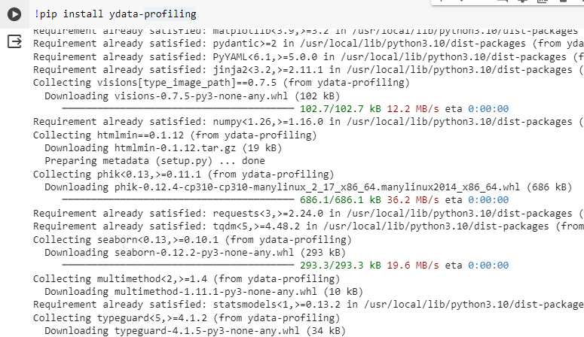

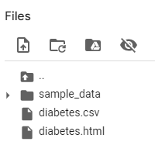

Perform a basic data profiling to understand the structure of the dataset, including the number of rows, columns, and data types.

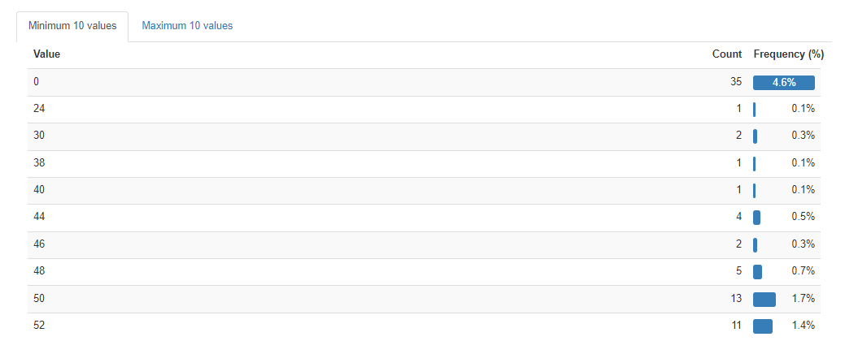

Compute summary statistics (mean, median, standard deviation, etc.) for each numerical variable.

Identify missing values and their distribution across variables.

**TASK # 2:**

Calculate pairwise correlation coefficients between all numerical variables.

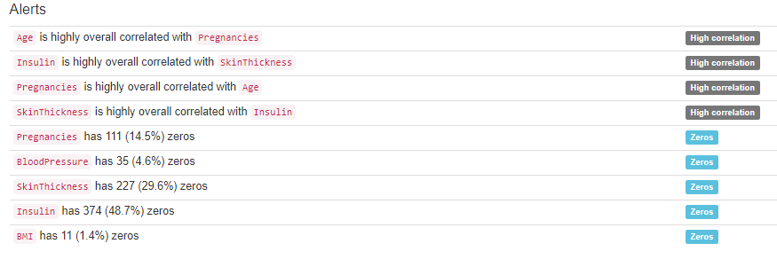

Create a correlation matrix and visualize it using a heatmap.

Identify highly correlated variables and discuss their potential impact on model performance.



**TASK 3:**

Identify potential outliers in the dataset using appropriate techniques, such as box plots

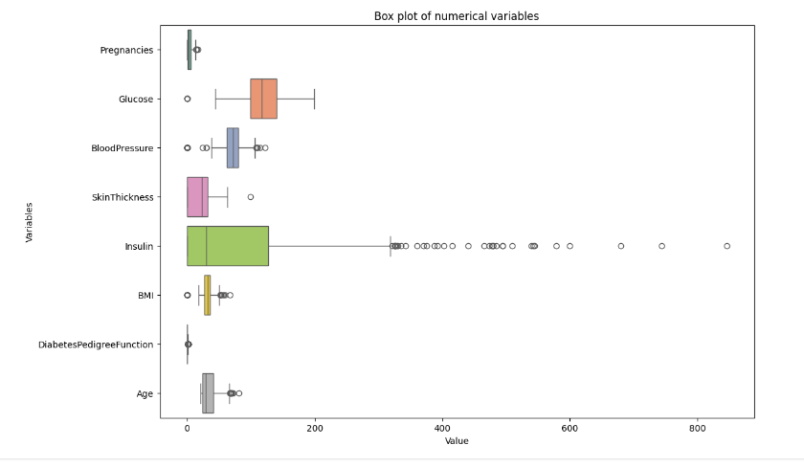

Visualize the distribution of each numerical variable to identify any extreme values.

import pandas as pd

import matplotlib.pyplot as plt

import seaborn as sns

numerical_columns = ['Pregnancies', 'Glucose', 'BloodPressure', 'SkinThickness', 'Insulin', 'BMI', 'DiabetesPedigreeFunction', 'Age']

for column in numerical_columns:

    plt.figure(figsize=(8, 6))

    sns.histplot(df1[column], kde=True, bins=20, color='skyblue')

    plt.title(f'Distribution of {column}')

    plt.xlabel(column)

    plt.ylabel('Frequency')

    plt.show()

plt.figure(figsize=(12, 8))

sns.boxplot(data=df1[numerical_columns], orient='h', palette='Set2')

plt.title('Box plot of numerical variables')

plt.xlabel('Value')

plt.ylabel('Variables')

plt.show()

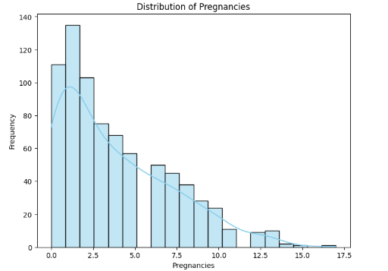

**Discuss the potential impact of outliers on the analysis and modeling process.**

Outliers can skew statistical measures such as the mean and standard deviation, potentially leading to biased estimates.

They can influence the results of certain statistical tests and machine learning algorithms, leading to incorrect conclusions or poorly performing models.

Depending on the context, outliers may represent valid data points or errors in measurement. It's crucial to understand the nature of outliers before deciding whether to remove or transform them.

Outliers may also indicate interesting or important phenomena in the data that warrant further investigation.

**TASK 4:**

* 1. Analyze the distribution of the target variable (diabetes or non-diabetes).
  2. Visualize the target variable distribution using a histogram or a bar chart.
  3. Identify any potential imbalance in the target variable and discuss its impact on model performance.

import matplotlib.pyplot as plt

import seaborn as sns

plt.figure(figsize=(6, 4))

sns.countplot(data=df1, x='Outcome', palette='Set2')

plt.title('Distribution of Outcome (Diabetes vs Non-Diabetes)')

plt.xlabel('Outcome')

plt.ylabel('Count')

plt.show()

outcome_counts = df1['Outcome'].value_counts()

total_samples = len(df1)

proportion_diabetes = outcome_counts[1] / total_samples

proportion_non_diabetes = outcome_counts[0] / total_samples

print("Proportion of Diabetes cases:", proportion_diabetes)

print("Proportion of Non-Diabetes cases:", proportion_non_diabetes)

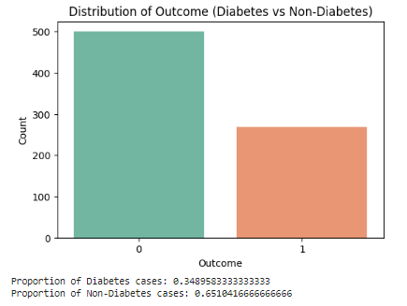

**Imbalanced classes** can lead to **biased models**, where the model may become overly sensitive to the majority class and perform poorly on the minority class.

In the case of medical diagnosis like diabetes detection, misclassification of positive cases (diabetes) can have significant consequences, potentially leading to missed diagnoses or delayed treatments.

Algorithms trained on imbalanced data may prioritize accuracy over other performance metrics, resulting in poor sensitivity or specificity, which are crucial for medical applications.

Techniques such as resampling (e.g., oversampling minority class, undersampling majority class), using different evaluation metrics (e.g., precision, recall, F1-score), or employing algorithms designed to handle imbalanced data (e.g., ensemble methods, cost-sensitive learning) can help mitigate the impact of class imbalance and improve model performance.